Exercise 5a : Themes

One of the most powerful aspects of Codename One is its support for custom themes. In this exercise, we will use some graphic assets and fonts to create a custom theme that looks like:

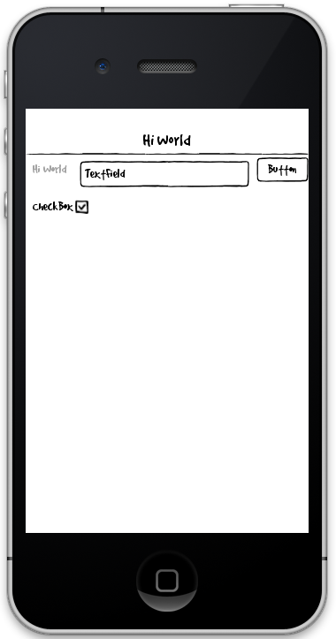

Steps:

1. Override the Form, TextField, Label, Button, Title, TitleArea, and CheckBox styles to achieve this look.
2. Override the relevant constants for the checked and unchecked images of checkboxes.

References:

1. You can download the Good Dog font at <https://github.com/shannah/oscon2014-ex5/blob/master/Jolly%20UI%20Free/fonts/good_dog/GOODDP__.ttf>
2. You can download the necessary image assets from https://github.com/shannah/oscon2014-ex5/tree/master/Jolly%20UI%20Free/exports
3. The graphics for this theme were obtained from the Jolly UI Free kit (<http://handdrawngoods.com/store/jolly-ui-free-hand-drawn-ui-kit/>).
4. The font is Good Dog, obtained here: <http://www.dafont.com/good-dog.font>